AI Booking Automation System
Al Annabi Tourism ,N8N Automation Report
Gmail • Outlook • n8n • OpenAI • Google Sheets

Field | Details
Trigger | Incoming emails across multiple Gmail and Outlook inboxes
Platform | N8N
Integrations | Gmail (×4), Microsoft Outlook (×4), OpenAI, Google Sheets
AI Model | OpenAI GPT (via AI Agent node)
Client | Al Annabi Tourism ,Doha, Qatar
Output | Structured booking data appended to Google Sheets; cancellations updated in real time

1 Project Overview
This project automates booking management for Al Annabi Tourism by eliminating manual email processing across multiple Gmail and Outlook accounts. All inboxes are integrated into n8n, which continuously monitors incoming booking and cancellation emails.

An AI agent powered by OpenAI extracts structured data such as booking reference, tour details, customer info, and status from each email. The extracted data is automatically stored and organized in Google Sheets for centralized tracking. Cancellation emails are also detected and used to update the booking status in real time.

This system prevents missed bookings, reduces human error, and significantly improves operational efficiency across all platforms and inboxes.

2 Automation Flow ,End to End
# | Node / Action | Description
1 | Email Trigger | Gmail and Outlook inboxes continuously monitored for new incoming emails
2 | HTML Extraction | Raw email HTML content extracted and cleaned for AI processing
3 | Edit Fields | Relevant metadata fields (sender, subject, timestamp) prepared and structured
4 | Merge Node | Inputs from all inbox triggers merged into a single unified pipeline
5 | AI Annabi Tourism Agent | Primary AI agent determines if the email is a booking or a cancellation
6 | Cancellation Agent | Dedicated AI agent handles cancellation emails ,extracts booking reference and status
7 | Filter / If Node | Routes email to correct branch: new booking or cancellation update
8 | AI Agent ,Data Extraction | Extracts structured fields: booking reference, tour name, type, date, time, customer info, platform
9 | Append Row in Sheet | New booking data appended as a new row in the Google Sheets tracker
10 | Cancelled ,Update Sheet | Cancellation status updated against the existing booking reference in Google Sheets

3 Workflow Diagrams
3.1 Outlook → Sheets Workflow
Four Microsoft Outlook inboxes are monitored in parallel. Emails are extracted, merged, classified by AI, and routed to either the booking or cancellation branch before being written to Google Sheets.

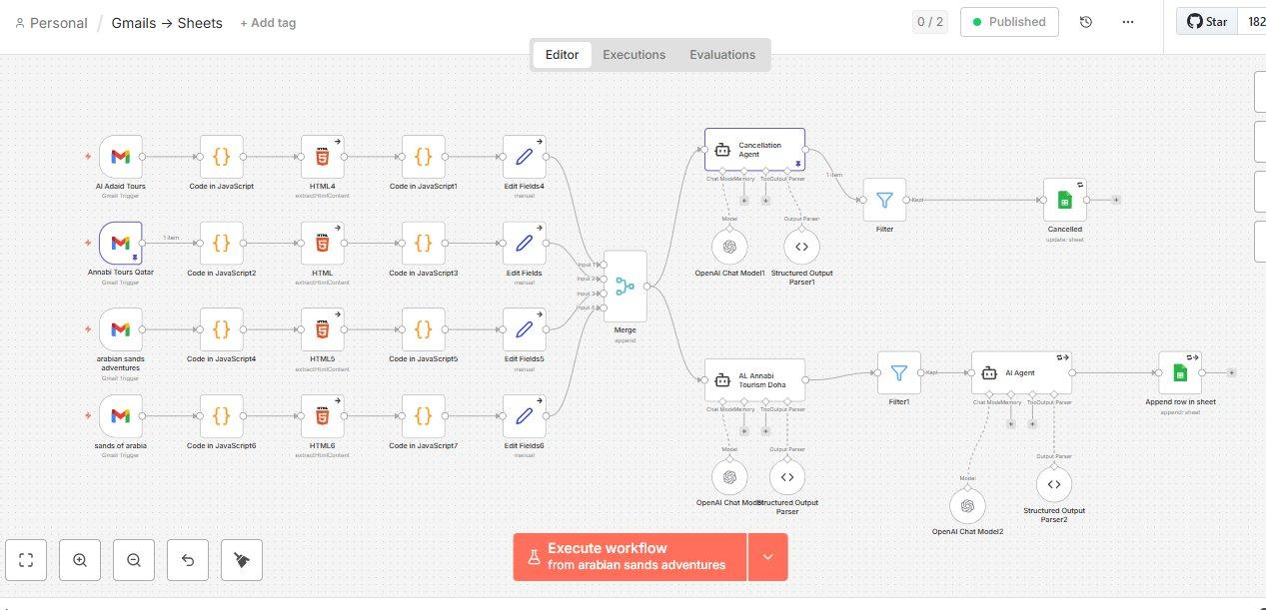
Workflow 1 ,Outlook → Sheets: Four Outlook triggers merged through AI classification into Google Sheets
3.2 Gmail → Sheets Workflow
Four Gmail accounts (AI Adaid Tours, Annabi Tours Qatar, Arabian Sands Adventures, Sands of Arabia) feed into the same unified AI pipeline for booking extraction and sheet updates.

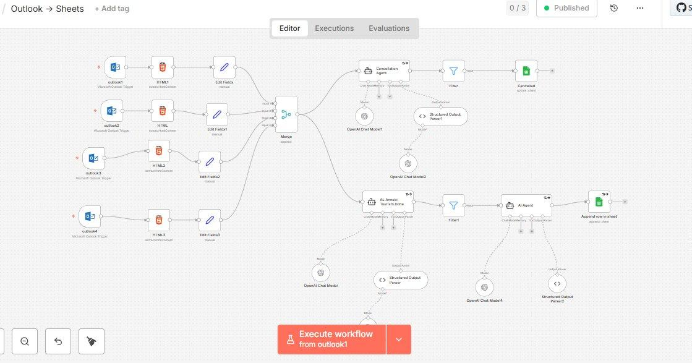
Workflow 2 ,Gmail → Sheets: Four Gmail triggers processed through AI agents into Google Sheets
3.3 Outlook Cancellation → Sheets Workflow
A dedicated cancellation workflow triggers on form submission, loops over messages, extracts the cancellation details via AI, and updates the existing booking row status to Cancelled in Google Sheets.

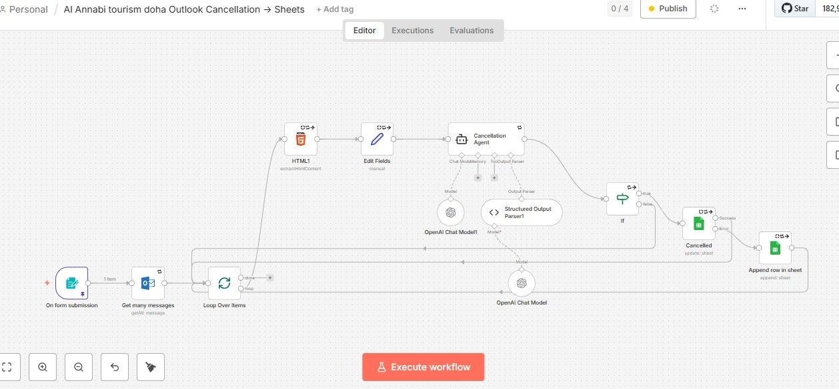
Workflow 3 ,Outlook Cancellation → Sheets: Dedicated cancellation detection and status update pipeline

4 Data Captured ,Google Sheets Fields
The AI agent extracts and maps the following 14 structured fields from every booking email into the centralized Google Sheets tracker:

Google Sheets Field | Data Captured
Booking Reference | Unique booking ID extracted from email (e.g. GYGWZA9NNHK4, VIA-73007039)
Date | Tour date parsed from email content
Tour Name | Full tour title as listed in the booking confirmation
Tour Type | Group, Private, or other classification
Tour Hours | Morning, Afternoon, Evening, or Sunset
Start Time | Scheduled tour start time
End Time | Scheduled tour end time
Pick-Up Location | Hotel or meeting point for customer pickup
Status | Number of passengers / group size
Platform | Booking source ,GYG, Viator, Shouf, or other
Page | Sub-page or operator (e.g. Annabi Tours Qatar, Arabian Sands Adventures)
Notes | Inclusions, extras, and special requirements from the booking
Phone | Customer contact number extracted from the email
Appointment Status | Current status ,Booked or Cancelled (updated in real time)

5 Google Sheets Output
5.1 Booking Data View
Each processed email generates a new row in the tracker with booking reference, date, tour name, type, hours, start/end time, and pick-up location automatically populated.

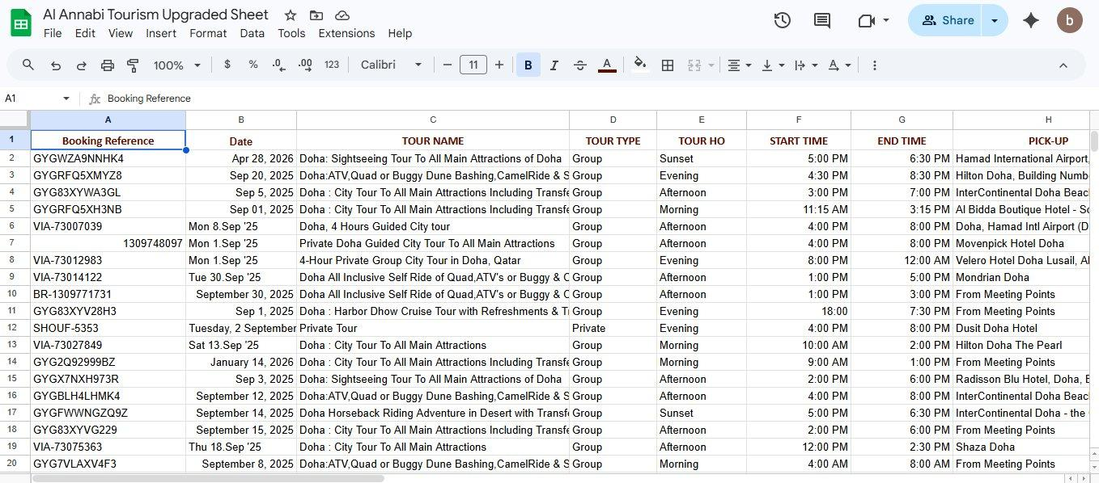
Google Sheets ,Booking data columns (A–H): Reference, Date, Tour Name, Type, Hours, Start/End Time, Pick-Up
5.2 Status & Platform View
The right-hand columns track platform source, page, notes, phone number, and real-time appointment status. Cancelled bookings are highlighted in red; confirmed bookings appear in green.

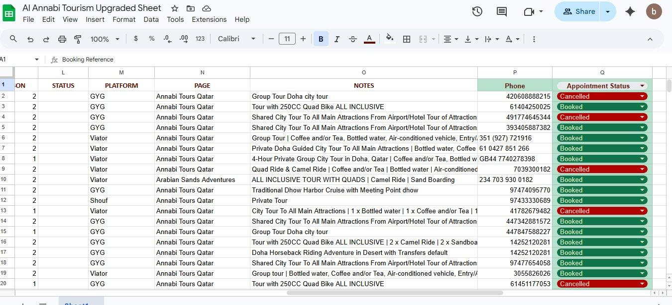
Google Sheets ,Status columns (L–Q): Status, Platform, Page, Notes, Phone, Appointment Status

6 Challenges & How the Workflow Addresses Them

- Emails arrive across 8 separate inboxes with no unified format:
→ All Gmail and Outlook triggers feed into a single Merge node, creating one unified pipeline regardless of the source inbox. HTML extraction normalizes content before AI processing.
- Booking and cancellation emails must be distinguished and handled separately:
→ A dedicated Cancellation Agent runs in parallel with the main booking agent. A Filter node routes each email to the correct branch ,new booking or status update ,preventing data conflicts.
- Unstructured email HTML contains inconsistent data layouts across platforms:
→ The AI agent is prompted to extract exactly 14 structured fields regardless of email format, handling variations across GYG, Viator, Shouf, and direct booking platforms.
- Cancellations must update existing records rather than create duplicates:
→ The cancellation branch identifies the booking reference from the email and uses an update operation on Google Sheets to change the Appointment Status field to Cancelled in the correct row.
- Multiple accounts may receive the same booking simultaneously:
→ The Merge node and AI classification layer deduplicate and classify inputs before any sheet operation, preventing double entries from overlapping inbox triggers.

7 Tools & Integrations
Tool / Service | Role in Workflow
n8n | Core workflow automation engine ,orchestrates all triggers, routing, and integrations
Gmail (×4 accounts) | Monitors AI Adaid Tours, Annabi Tours Qatar, Arabian Sands Adventures, Sands of Arabia inboxes
Microsoft Outlook (×4) | Monitors four Outlook-based inboxes for booking and cancellation emails
OpenAI (AI Agent) | Extracts and classifies structured booking data from unstructured email content
Google Sheets | Centralized tracker ,stores all booking rows and receives real-time cancellation updates

8 System Architecture Summary
TRIGGER SOURCE | N8N AUTOMATION | OUTPUT
• Gmail ,AI Adaid Tours  • Gmail ,Annabi Tours Qatar  • Gmail ,Arabian Sands Adventures  • Gmail ,Sands of Arabia  • Outlook ,4 Accounts | • HTML Extraction  • Merge All Inboxes  • AI Classification Agent  • Cancellation Agent  • Filter / Routing Node  • AI Data Extraction Agent | • New Row Added to Sheet  • Booking Status Updated  • Cancellations Flagged  • 14 Fields Structured  • Zero Manual Input

